

**DIGITAL ASSIGNMENT 1**

**Name: Soumyadeep Ganguly**

**Reg No: 24MDT0082**

**Course: Big Data Analytics Lab**

**Course Code: PMDS507P**

**Step 1:** Check java version

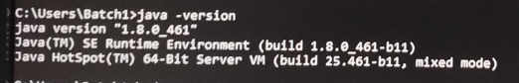

**Step 2:** Check Hadoop version

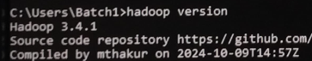

**Step 3:** Go to Command Prompt and type: start-dfs.cmd

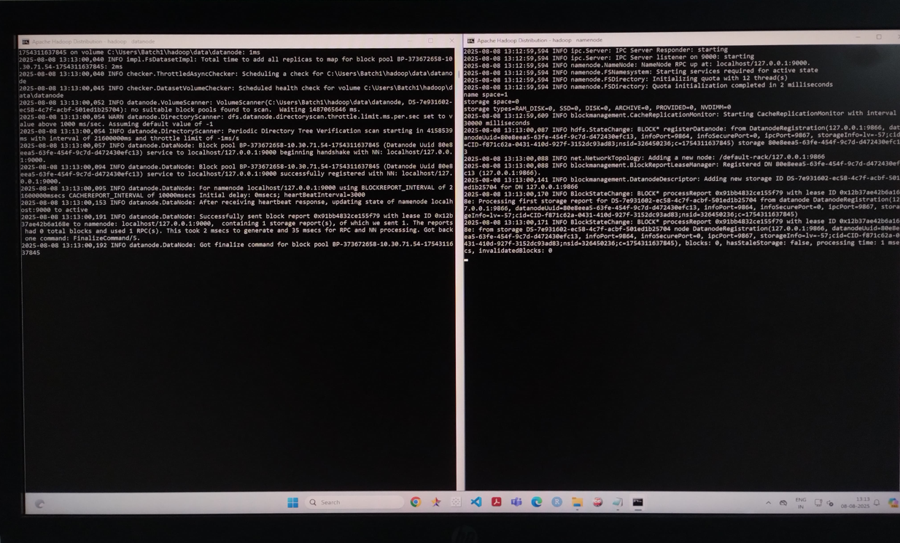This command will start the “NameNode” and “DataNode” in separate windows.

**Step 4:** Now type: start-yarn.cmd

It will start the “NodeManager” and “ResourceManager” in 2 separate windows.

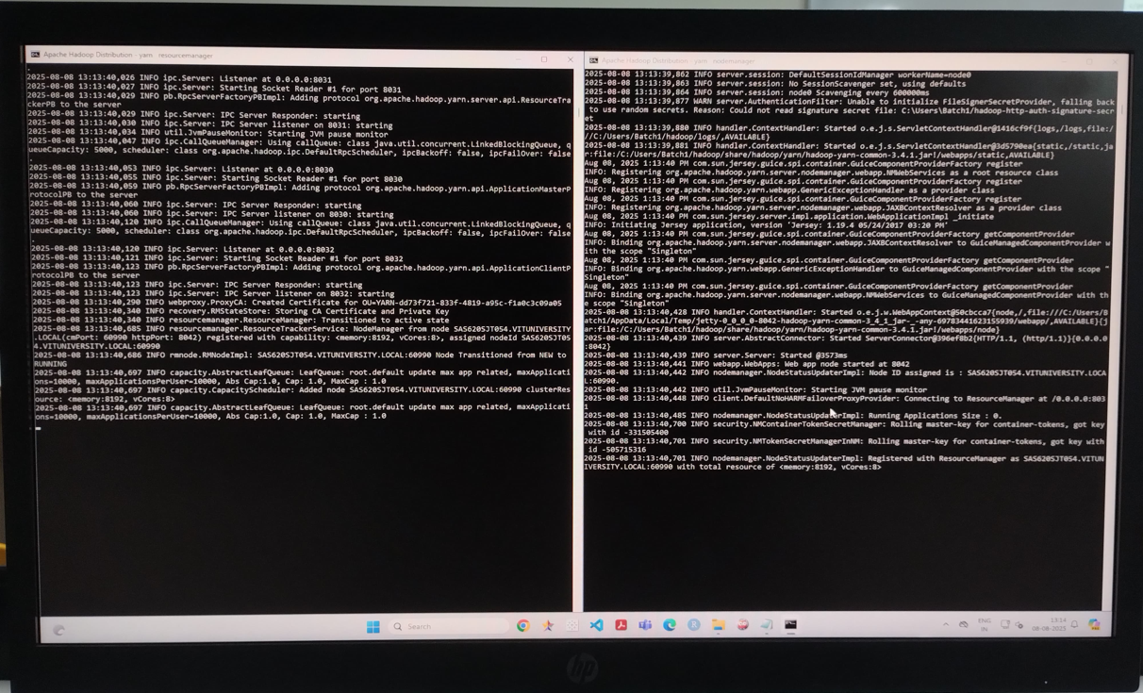

**Step 5:** Now type: jps

It will display a list of all currently running Java processes on the local system.

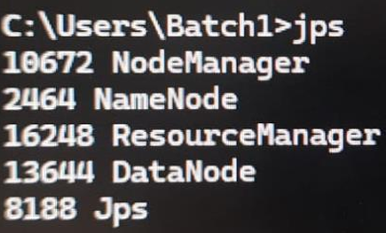

**Step 6:** Configure **core-site.xml** under the Hadoop folder

<property>

<name>fs.defaultFS</name>

<value>hdfs://localhost:9000</value>

</property>

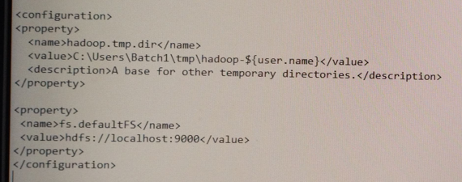

**Step 7:** Configuration for **hdfs-site.xml** file.

<property>

<name>dfs.replication</name>

<value>1</value>

</property>

<property>

<name>dfs.namenode.name.dir</name>

<value>C:\users\batch1\hadoop\data\namenode</value>

</property>

<property>

<name>dfs.namenode.name.dir</name>

<value>C:\users\batch1\hadoop\data\datanode</value>

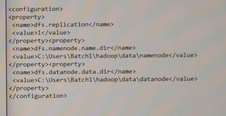</property>

**Step 8:** Configuration for **mapred-site.xml**

<property>

<name>mapreduce.framework.name</name>

<value>yarn</value>

</property>

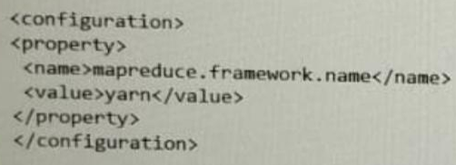

**Step 9:** Configuration for **yarn-site.xml** file

<property>

<name>yarn.nodemanager.aux-services</name>

<value>mapreduce_shuffle</value>

</property>

<property>

<name>yarn.nodemanager.aux-services.mapreduce.shuffle.class</name>

<value>org.apache.hadoop.mapred.ShuffleHandler </value>

</property>

